Unit 2: Measurement of Economic Performance

GDP - National Income Accounts

Topic 1: Circular Flow

Difficulty Level 2
- In a simple circular-flow diagram, households _______ goods and services and _______ factors of production.
  - buy; buy
  - buy; sell
  - sell; sell
  - sell; buy
  - barter; sell
- According to the circular flow model, which of the following statements is true?
  - Households are demanders in both the factor and product markets.
  - Households are demanders in the product markets and suppliers in the factor markets.
  - The government is a demander in the product market but not in the factor market.
  - Firms are demanders in the product market in suppliers in the factor markets.
  - Firms are suppliers in both the factor and product markets.
- Which of the following is NOT a part of a household’s income?
  - wages
  - savings
  - profit
  - rent
  - interest
Use the diagram below to answer the following questions.
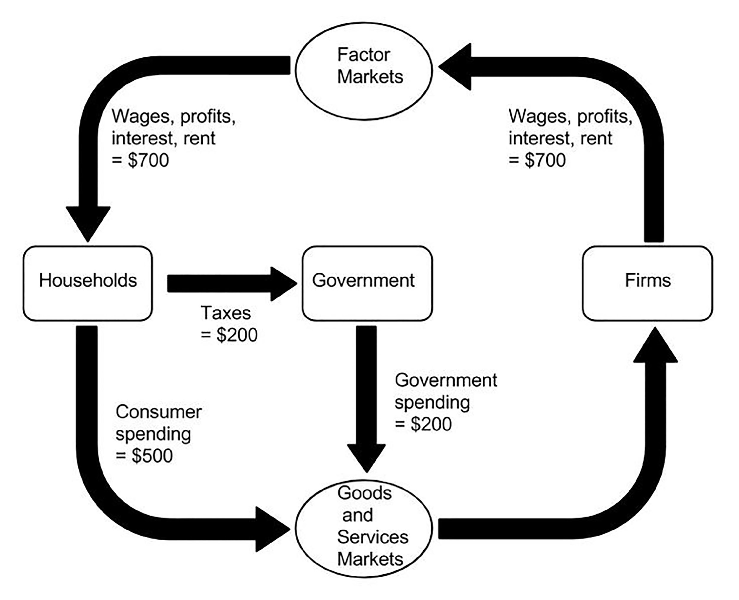
- According to the circular flow diagram, how does the government fund its spending?
  - Consumer spending
  - Sales of factor resources
  - Profit
  - Taxes
  - Sales of goods and services
- According to the circular flow diagram, what is the GDP in this economy?
  - $200
  - $500
  - $700
  - $1200
  - $1600
- According to the circular flow diagram, what is the GDP in this economy?
  - $725
  - $800
  - $875
  - $900
  - $1600

Difficulty Level 3
- Which of the following economic behaviors is considered to be a leakage from the circular flow model?
  - saving
  - consumption spending
  - investment spending
  - government spending
  - imports
Use the diagram below to answer the following questions.
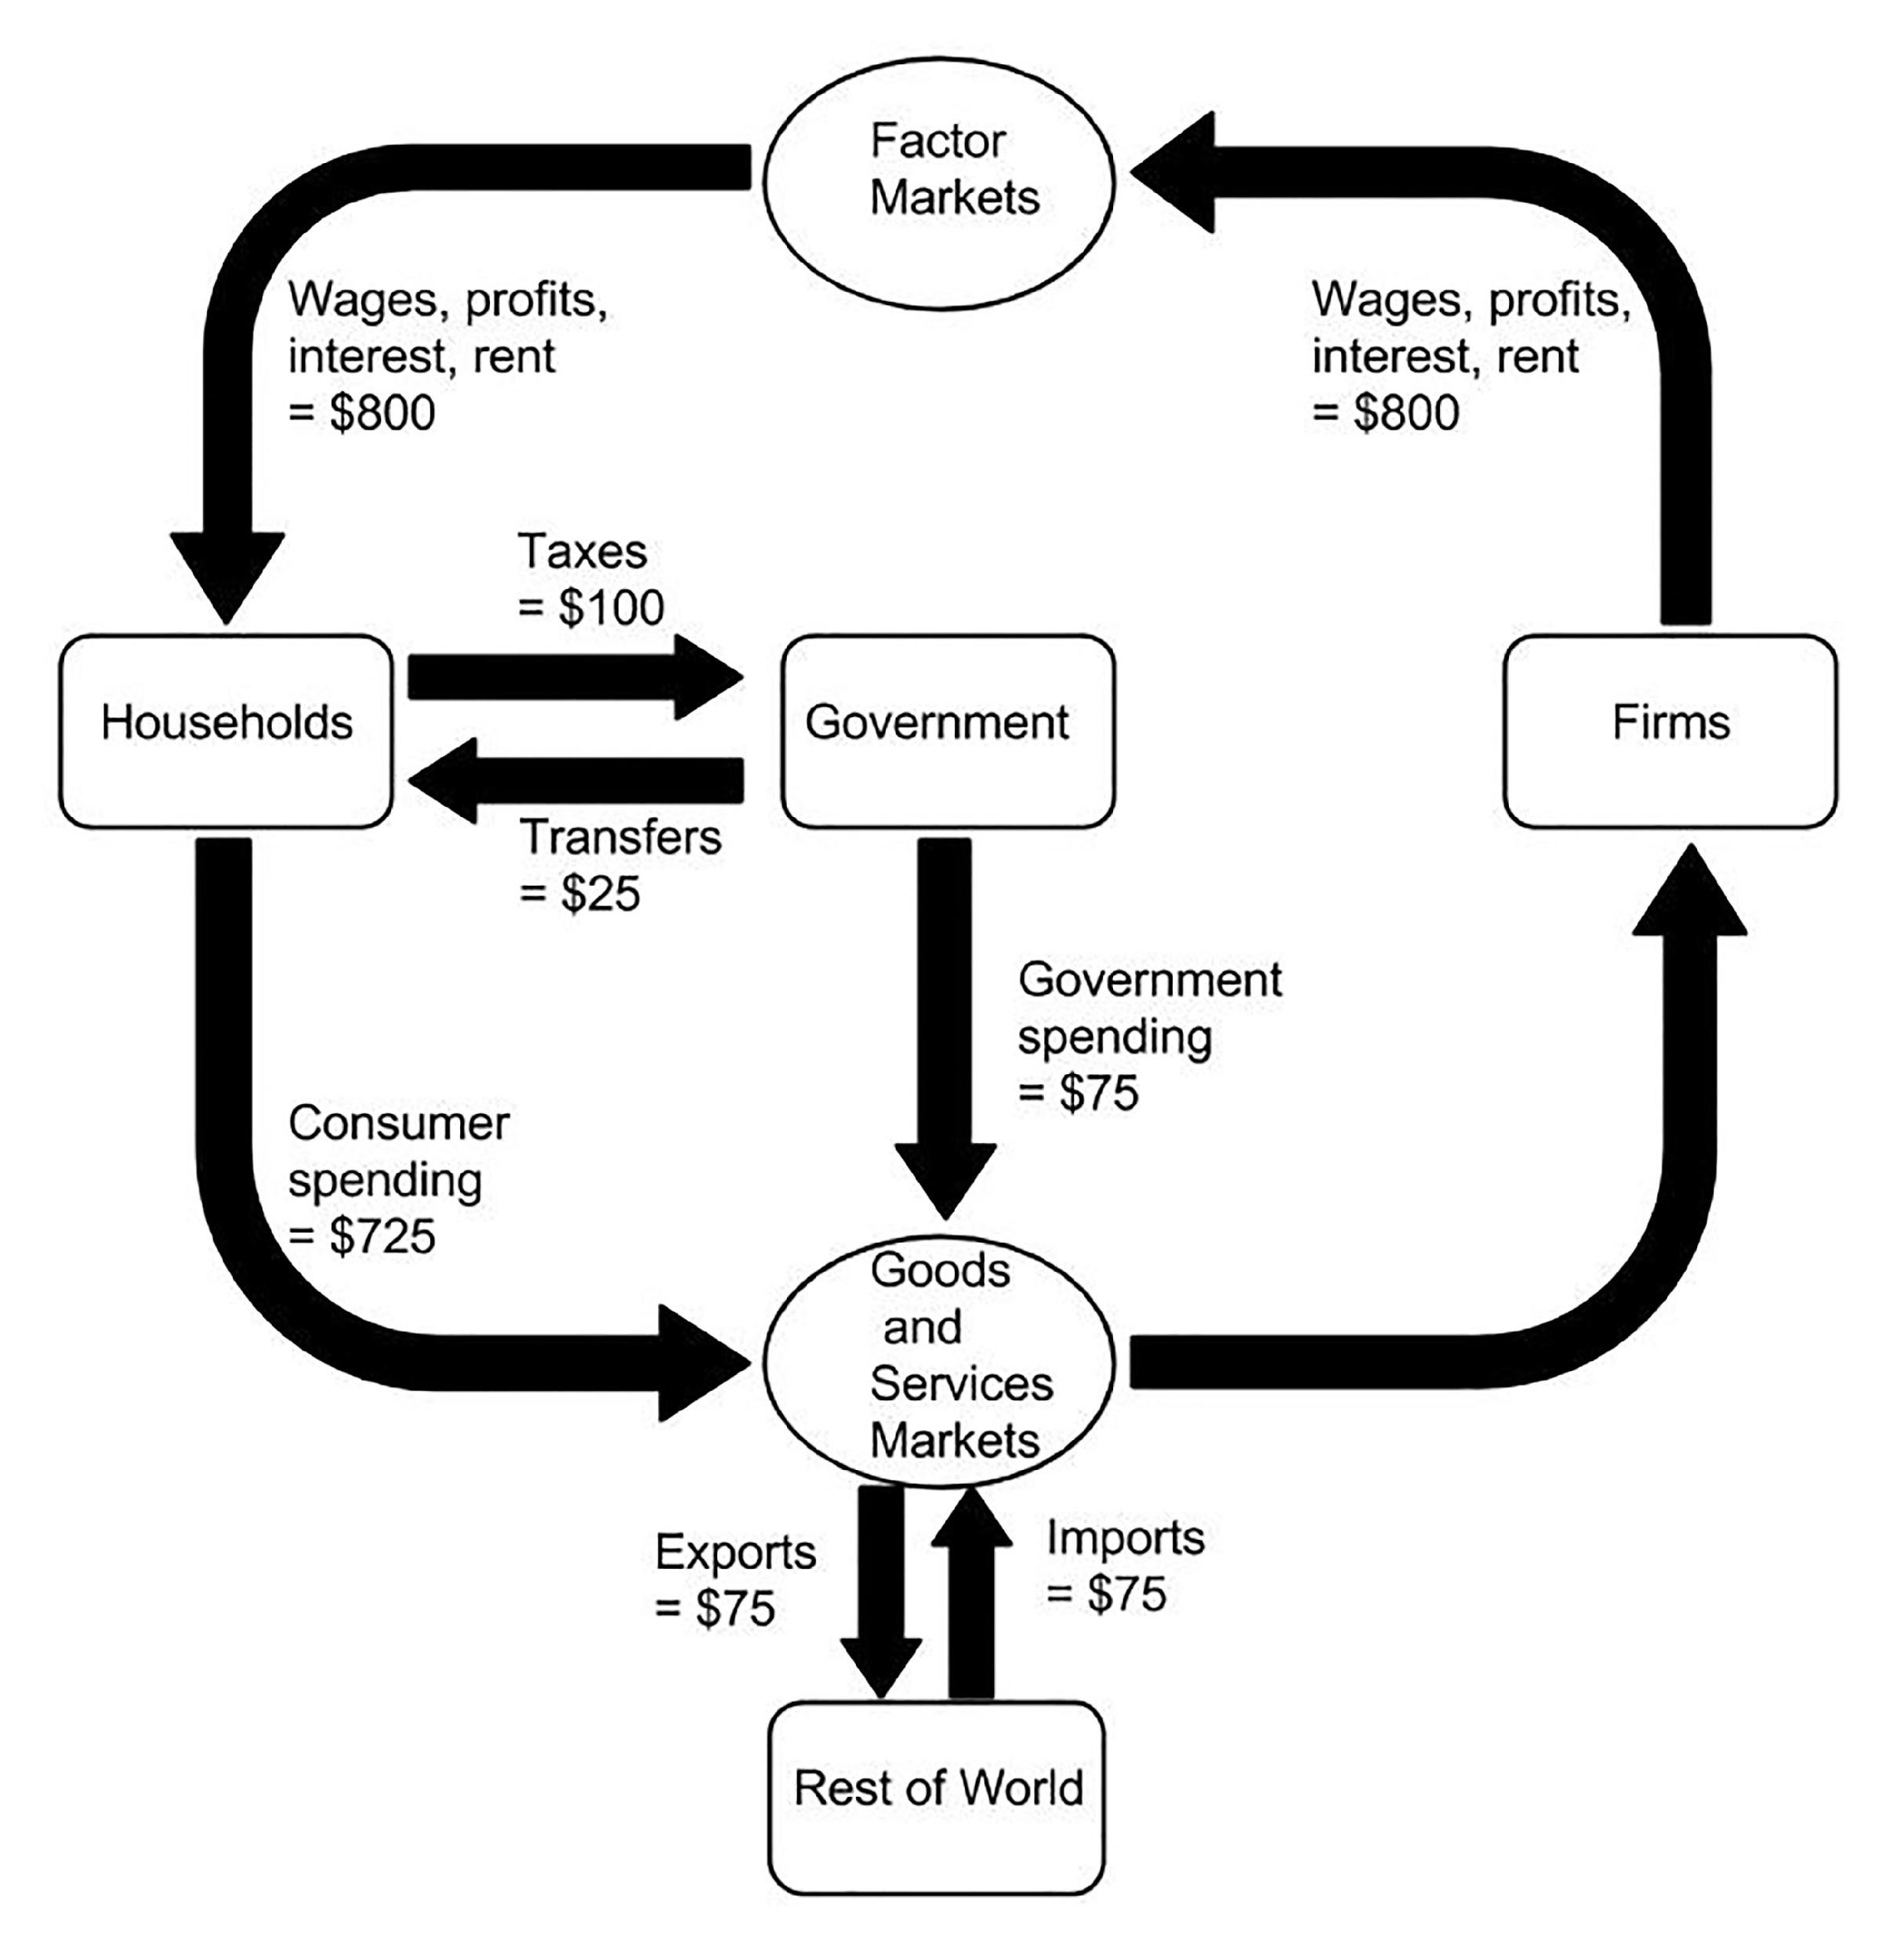

- According to the circular flow diagram, which of the following statements is true?
- A household’s income equals its expenditures.
- The government’s income equals its expenditures.
- Net exports are equal to $75.
  - II only
  - III only
  - I and II only
  - I, II, and III

Topic 2: GDP

Difficulty Level 1
- Gross domestic product is defined as
  - consumer spending + transfers + government spending + exports – imports
  - consumer spending + investment spending + government spending + exports + imports
  - consumer spending + investment spending + government spending + exports – imports
  - consumer spending + government spending + investment spending + imports – exports
  - consumer spending + government spending + financial spending + exports – imports

Difficulty Level 2
Use the table below to answer the following question.
Wages and Salaries  Profits  Consumption Spending  Imports  Exports  Unemployment Benefits  Interest  Government Purchases of Goods and Services  Sales Taxes  Rent  Investment Spending | $1000  $1600  $1800  $200  $100  $100  $400  $1100  $300  $200  $400
- Using the information in the table above, what is the GDP in this economy?
  - $2900
  - $3200
  - $3300
  - $3400
  - $4500
- In an economy with a GDP of $4000, income from wages is $1200, rent is $1100, and interest is $1000. What are profits equal to?
  - $700
  - $900
  - $1000
  - $3300
  - $4000
Use the table below to answer the following questions.
Personal consumption spending  Domestic investment spending  Imports  Exports  Local government purchases of goods and services  Federal Government purchases of goods and services | $600  $300  $40  $20  $300  $200

- According to the data in the table above, how much of gross domestic product is the result of government spending?
  - $55
  - $100
  - $200
  - $300
  - $500
- According to the data in the table above, what is the value of net exports?
  - -$40
  - -$20
  - $40
  - $20
  - $0
- According to the data in the table above, what is the gross domestic product in this economy?
  - $600
  - $1180
  - $1380
  - $1420
  - $1460

Difficulty Level 3
- A farmer sells cucumbers to a food processor for $1.50 per pound. The food processor makes the cucumbers into pickles and sells each jar of pickles to a grocery store for $2.50. The grocery store sells each jar of pickles for $3.00. How much do these transactions add to GDP?
  - $1.50
  - $3.00
  - $5.50
  - $7.00
  - These transactions do not add any value to GDP.

Topic 3: Components of gross domestic product

Difficulty Level 2
- Which of the following examples is classified as consumption spending that would be counted toward the United States’ GDP this year?
  - The purchase of a computer by an accounting firm.
  - The purchase of a computer by a police department.
  - The purchase of a computer by a high school student.
  - The purchase of a computer produced in the United States by a German student.
  - The purchase of a used computer.
- Which of the following examples is classified as investment spending that would be counted toward this year’s GDP?
  - Leonard purchased a home built in 1927.
  - Hillary purchased a new dishwasher for her apartment.
  - Pierre purchased a new luxury car.
  - Ace Company purchased 9,000 shares of Microsoft stock.
  - Damian purchased a new oven for his restaurant.
- Which of the following is not considered a part of this year’s GDP?
  - A family’s purchase of a new car.
  - A factory’s purchase of a new drill press.
  - A child’s purchase of a school lunch.
  - A college student’s purchase of a used textbook.
  - A government’s purchase of a new copy machine.
- A lawn mower purchased by a private individual is considered to be
  - consumption spending
  - investment spending
  - a purchase of a financial asset
  - an import
  - human capital
- Which of the following transactions would cause an increase in a nation’s gross domestic product?
  - A grandfather sells his house to his grandson.
  - An auto dealer sells a car from last year’s inventory.
  - Mrs. Jones buys a share of stock in a computer company.
  - The government purchases new computer equipment for use by public schools.
  - Consumers purchase more imported cheese.
- Which of the following transactions is NOT included in the United States’ gross domestic product for the year 2000?
  - The rent paid in 2000 by tenants in a house built in 1980.
  - The value of an old desk sold by an antique shop.
  - The value of a new sofa purchased from a furniture showroom in 2000.
  - Commissions earned in 2000 by an auto salesperson.
  - The value of automobiles produced in 2000 entirely in the United States by a firm owned by German citizens.

Difficulty Level 3
- An automobile is produced in 2013, but is not sold until 2014. How is this automobile counted in GDP?
  - It is included in GDP as consumption spending in 2013.
  - It is included in GDP as investment spending in 2013.
  - It is included in GDP as investment spending in 2014.
  - It is excluded from GDP until it is sold in 2014.
  - It is excluded from GDP for both 2013 and 2014.

Topic 4: Real versus nominal gross domestic product

Difficulty Level 1
- Real GDP is nominal GDP adjusted for
  - net exports
  - real interest rates
  - inflation
  - unemployment
  - government spending
- Consider an economy that only produces two goods: record players and headphones. If 5 record players are sold at $20 each and 10 sets of headphones are sold at $10 each, then nominal GDP is
  - $30
  - $200
  - $250
  - $300
  - $500

Difficulty Level 2
Use the table below to answer the following question.
 | 1999 quantity | 1999 price | 2000 quantity | 2000 price
Record players | 5 | $20 | 10 | $20
Headphones | 10 | $10 | 10 | $20

- According to the data in the table, what is real gross domestic product in 2000, using 1999 as the base year?
  - $100
  - $150
  - $300
  - $400
  - $600

Difficulty Level 3
- If nominal gross domestic product is increasing at 8 percent per year and real gross domestic product is increasing at 4 percent per year, which of the following statements must be true?
  - The price level is increasing.
  - Unemployment is increasing.
  - The economy is experiencing stagflation.
  - The national debt is increasing.
  - Exports are increasing.
- If real GDP for a given year is $1000 and nominal GDP is $1500, then the GDP deflator is
1 | B | 6 | B | 11 | A | 16 | C | 21 | B | 26 | A
2 | B | 7 | A | 12 | E | 17 | E | 22 | B | 27 | C
3 | B | 8 | C | 13 | B | 18 | D | 23 | C | 28 | A
4 | D | 9 | C | 14 | C | 19 | A | 24 | B
5 | C | 10 | B | 15 | B | 20 | D | 25 | C

  - 67
  - 100
  - 150
  - 200
  - 250
- If the nominal GDP of an economy increased in 2000 relative to the previous year, it must be true that in this economy in 2000
  - the price level has increased and/or the real GDP has increased
  - the price level increased by a smaller percentage than the real GDP
  - both the price level and the real GDP have increased
  - neither the price level nor the real GDP has increased
  - the price level increased by a larger percentage than real GDP

Answers

